**Musical Experience and Identification of Emotional Prosody in Spoken Language**

Rena A. Lee

**Results**

**Amendments to Original Analysis Plan**

The analyses for this study focus on the correlations between years of musical experience, pitch discrimination ability, and emotion identification ability using pairwise Bayesian regressions. A direct comparison of pitch discrimination ability and emotion identification accuracy was not included in the original analysis plan, but upon review of the data we felt it was necessary to include the correlation between those two variables in our final analysis to reveal whether there is a meaningful relationship between the two. Based on previous literature, since musicians have been found to have better pitch discrimination ability (Slevc, 2012; Bianchi et al., 2016) and greater sensitivity to emotional prosody (Lima & Castro, 2011) than non-musicians, it was agreed upon that a correlation between pitch score and emotion identification accuracy would provide useful insight as to what specific characteristics of musicians may lend them advantages in speech perception. This additional analysis is the only discrepancy from our previously established analysis plan.

**Exclusionary Criteria and Demographics**

To process our data, demographic and behavioral data files were filtered and processed using R studio. A total of 126 participants were approved for this study from the 153 recruited. Two participants were excluded from this analysis for indicating that they have experience in a language other than English; three for entering erroneous answers to the demographic question concerning years of musical experience; and three for performing the task incorrectly. The data from two participants appeared in either the demographic data or the raw data, but not both (presumably due to program error on Prolific), so they were also excluded. After these exclusions, a total of 117 participants were included in this analysis. There were 65 female and 52 male participants.

**Tables and Figures**

Table 1. Descriptive statistics of demographic and performance data for the 117 participants.

|  |  |  |
| --- | --- | --- |
|  | *Mean* | *SD* |
| *Age (Years)* | 35.25 | 12.98 |
| *Musical Experience (Years)* | 3.20 | 6.50 |
| *Pitch Score (from 1-12)* | 8.22 | 2.43 |
| *Emotion ID Accuracy (%)* | 50% | 13% |

The processed data was entered into JASP to calculate Bayesian correlation pairs, with a prior belief that all three pairs of the variables (pitch discrimination score vs. years of musical experience, years of musical experience vs. emotion identification accuracy, and pitch discrimination score vs. emotion identification accuracy) would correlate positively. The results of these analyses are displayed and briefed below.

Table 2. A Bayesian Pearson correlation between years of musical experience and pitch discrimination ability.

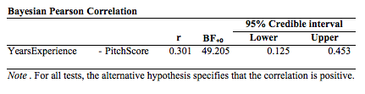

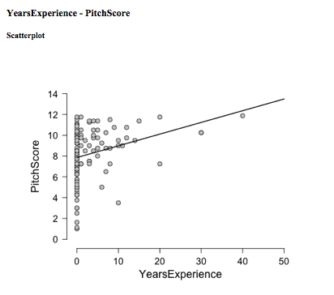

Fig. 1. Scatterplot of years of musical experience by pitch score.

A Bayes Factor (BF) of 49.205, *r*(117) = 0.301, is significant support for the alternative hypothesis, that years of musical experience and pitch discrimination score are positively correlated. The plot (Fig. 1) also illustrates this supposed relationship. A BF Robustness Check was also run, which revealed that the max BF of stretched beta prior widths (r values) ranging from 0 to 2 was 84.147, which indicates strong to very strong evidence for the alternative, while there was only anecdotal evidence for the null (additional figures are available at our OSF, linked below). In this correlation pair alone, we found reason to reject the null hypothesis.

Table 3. A Bayesian Pearson correlation between years of musical experience and emotion identification accuracy score.

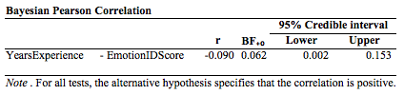

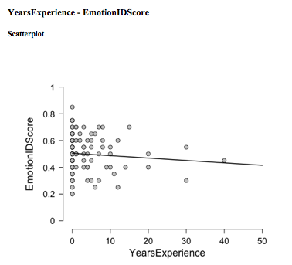

Fig. 2. Scatterplot of years of musical experience by emotion identification accuracy score.

It was found that years of musical experience and emotion identification accuracy were slightly negatively correlated, which is inconsistent not only with our hypothesis but with previous literature positing a significant effect of the former on the latter (Lima & Castro, 2011; Thompson et al., 2004; Strait et al., 2009; Nolden et al., 2017; Pinheiro et al., 2015). The BF of 0.062 suggests that the null hypothesis is about 16 times more likely than the alternative. A BF Robustness Check and a Sequential Analysis showed only anecdotal evidence in support of the alternative hypothesis, and strong evidence in support of the null hypothesis. This analysis provides reason to fail to reject the null hypothesis.

Table 4. A Bayesian Pearson correlation between pitch discrimination ability and emotion identification accuracy score.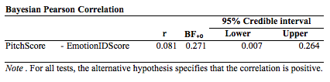

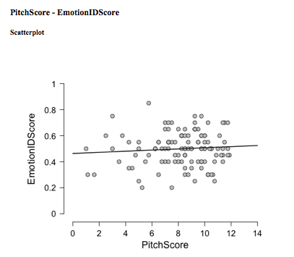

Fig. 3. Scatterplot of years of pitch discrimination score by emotion identification accuracy score.

Similar to the previous analysis, a BF of 0.271 provides relative support for the null hypothesis. While there does appear to be a positive correlation, it is very weak, *r*(117) = 0.081, and is not significant. The data are almost 4 times more likely under the null hypothesis. This supports the null, but relative to the other analyses this one does not provide as much meaningful information. The BF Robustness Check and Sequential Analysis indicate that there is only moderate evidence supporting the null hypothesis.

Supplementary materials, including analysis plans, registered report, additional JASP figures, unprocessed data, stimuli, and experiment codes, are available on our OSF: <https://osf.io/wj2m7/?view_only=e843bb0eb1ce4f4d80039b1903b33ab6>.

The analysis code used for these results and discussion are available at: <https://osf.io/tyrf2/>.

**Discussion**

The main finding of this study was that years of musical experience and pitch discrimination ability are positively correlated, which corroborates much of the literature reviewed in our introduction available on our OSF (Slevc, 2012; Bianchi et al., 2016). Years of musical experience, though very broadly conceived, predicted the averaged correctness score for the last 8 trials of the 20 included in the task. However, taking into consideration all of the above analyses, it seems that we must fail to reject the null hypothesis; there is not sufficient evidence for the existence of effects of neither musical experience nor pitch discriminatory ability on the sensitivity of an individual to emotion prosodic cues in spoken language. Our results fail to replicate the findings of Thompson et al. (2004) and Strait et al. (2009), as there does not seem to exist a direct link between musical training and sensitivity to emotional prosody. This suggests, then, that the processes involved in emotion perception in speech are different from those involved in music and pitch detection. Our results pose as a counter to studies implicating musical training as an enhancer to linguistic (Delogu, Lampis, & Belardinelli, 2010; Lima & Castro, 2011; Magne, Schön, & Besson, 2006; Marie et al. 2011) and other non-musical (Benz et al. 2016) cognitive functions. Further evidence weakening the claim made by Thompson et al. (2004) includes musical training failing to improve social skills in children (Schellenberg, 2004), suggesting that musical skills do not directly impact emotional skills in developing brains.

Though our methods and analyses were meticulously planned, there remain some limitations to our study. Because of the remote nature of our study (conducted online), it was impossible to ensure that participants were properly engaged in the given tasks or to aid in identifying and correcting user errors. Moreover, it is worth noting that the emotions we chose to include in our emotion identification task do not represent the extremely large range of emotion that speech can express. If we had chosen more subtle emotional differences (ie. happiness vs. elation, annoyance vs. anger, etc.), we may have received more meaningful information as to whether musical experience predicts emotion identification accuracy.

Another limitation of our study was the filtering parameters of Prolific. This was a major reason as to why we set years of musical experience as a continuous variable (and thereby using correlations instead of significance tests) instead of grouping individuals into musician and non-musician categories like in other experimental designs (Marques et al. 2007; Bianchi et al. 2016). Musical experience was self-reported and only included years of musical experience, but subjective experiences in musical experience may vary greatly among participants, especially whether they are musical professionals or hobbyists. Additionally, most of our participants reported they had no musical experience (almost 60%), so our subject pool is not widely representative of the musically trained community. If it were possible to account for these differences using the online survey system, we may have had more useful information comparing musicians and non-musicians. This in mind, it is important to take into consideration the musical expertise and skills of untrained listeners. Bigand (2003) notes important distinctions between the average non-musician and “experienced listeners,” who exhibited sophisticated abilities in processing subtle changes in musical structures similar to those of musical experts. While most of the participants had little to no musical experience, there were many instances in which their pitch scores were near perfect (Fig. 1.). If there were a metric for musical ability other than raw years of musical training, we could more precisely investigate the possible connections between musical and emotional intelligence.

Lastly, a small constraint was the timeline and budget; we elected to make musical experience a loosely defined variable in order to recruit the most participants as possible (to increase power) given the time frame and budget, but had we been allotted more time or funding, we may have been able to be more finical regarding our exclusionary criteria. In the end, we decided it was more important to recruit a large subject pool to preserve the expected power of our tests.

Trimmer & Cuddy (2008) observed results similar to ours in a study attempting to define the relationships (and lack thereof) of emotional intelligence, musical training, and emotional speech prosody. Our results are consistent with Trimmer & Cuddy (2008) as there was no correlation between raw years of musical experience with scores on an emotional prosody test. They reported that there was no association between music training and sensitivity to emotional prosody, and instead proposed that emotional intelligence was a reliable predictor of emotion identification in speech. Their experimental design inspires further research on the subject area we have explored; it may be useful to test for connections between emotional and musical intelligence by quantifying musical ability on more parameters than pitch discrimination and years of experience, and by quantifying emotional intelligence on more parameters than a simple multiple-choice emotion identification task. There are many existing surveys that could be distributed similarly to how we did on Prolific that more accurately captures emotional sensitivity, such as the [Mayer-Salovey-Caruso Emotional Intelligence Test or the Bar-On Emotional Quotient Inventory.](https://search.proquest.com/docview/614494444?pq-origsite=360link&accountid=14824" \l "REF_c25) Since it has been shown that emotion perception through heard speech is not affected by pitch discriminatory ability, we should explore other ways to relate pitch discrimination and musical ability and emotion identification, such as testing whether individuals with perfect pitch are more accurate at identifying subtle emotional difference and whether they score higher on emotional intelligence tests.

**References**

Benz, S., Sellaro, R., Hommel, B., & Colzato, L. S. (2016). Music makes the world go round:

The impact of musical training on non-musical cognitive functions-a review. Frontiers in Psychology, 6(JAN) doi:10.3389/fpsyg.2015.02023

Bianchi, F., Santurette, S., Wendt, D., & Dau, T. (2016). Pitch discrimination in musicians and

non-musicians: Effects of harmonic resolvability and processing effort. *Journal of the Association for Research in Otolaryngology*, *17*(1), 69-79.

Bigand, E. (2003). More About the Musical Expertise of Musically Untrained Listeners. *Annals*

*of the New York Academy of Sciences,* *999*(1), 304-312. doi:10.1196/annals.1284.041

Castro, S. L., & Lima, C. F. (2010). Recognizing emotions in spoken language: A validated set

of portuguese sentences and pseudosentences for research on emotional prosody. Behavior Research Methods, 42(1), 74-81. 10.3758/BRM.42.1.74. Database available at <https://link.springer.com/article/10.3758%2FBRM.42.1.74>

Curtis, M. E., and Bharucha, J. J. (2010). The Minor Third Communicates Sadness in Speech,

Mirroring Its Use in Music. *Emotion, 10*(3), 335-348. Retrieved from <http://www.curtislab.info/uploads/3/4/1/2/34122340/curtis_bharucha2010emotion.pdf>

Delogu, F., Lampis, G., & Belardinelli, M. O. (2010). From melody to lexical tone: Musical

ability enhances specific aspects of foreign language perception. *European Journal of Cognitive Psychology,* *22*(1), 46-61. doi:10.1080/09541440802708136

Forinash, K. Just Noticeable Difference. (n.d.). Retrieved March 31, 2018, from

<https://soundphysics.ius.edu/?page_id=914>

Jackendoff, R. (2009). Parallels and Nonparallels between Language and Music. *Music*

*Perception: An Interdisciplinary Journal,* *26*(3), 195-204. doi:10.1525/mp.2009.26.3.195

Lima C. F., Castro S. L. (2011) Speaking to the trained ear: musical expertise enhances the

recognition of emotions in speech prosody. *Emotion, 11*:1021–1031. Retrieved from

<https://www.researchgate.net/publication/51669915_Speaking_to_the_Trained_Ear_Musical_Expertise_Enhances_the_Recognition_of_Emotions_in_Speech_Prosody>

Loeffler, D. B. (2006). Instrument timbres and pitch estimation in polyphonic music (Doctoral

dissertation, Georgia Institute of Technology).

Magne, C., Schön, D., & Besson, M. (2006). Musician Children Detect Pitch Violations in Both

Music and Language Better than Nonmusician Children: Behavioral and

Electrophysiological Approaches. *Journal of Cognitive Neuroscience,* *18*(2), 199-211.

doi:10.1162/089892906775783660

Marie, C., Delogu, F., Lampis, G., Belardinelli, M. O., & Besson, M. (2011). Influence of

Musical Expertise on Segmental and Tonal Processing in Mandarin Chinese. *Journal of Cognitive Neuroscience,* *23*(10), 2701-2715. doi:10.1162/jocn.2010.21585

Marques, C., Moreno, S., Castro, S. L., & Besson, M. (2007). Musicians Detect Pitch Violation

in a Foreign Language Better Than Nonmusicians: Behavioral and Electrophysiological Evidence. *Journal of Cognitive Neuroscience,* *19*(9), 1453-1463. doi:10.1162/jocn.2007.19.9.1453

Musacchia, G., Sams, M., Skoe, E., & Kraus, N. (2007). Musicians have enhanced subcortical

auditory and audiovisual processing of speech and music. *Proceedings of the National Academy of Sciences,* *104*(40), 15894-15898. doi:10.1073/pnas.0701498104

Nolden, S., Rigoulot, S., Jolicoeur, P., & Armony, J. L. (2017). Effects of musical expertise on

oscillatory brain activity in response to emotional sounds. *Neuropsychologia, 103,* 96-105. 10.1016/j.neuropsychologia.2017.07.014

Pantev, C., Oostenveld, R., Engelien, A., Ross, B., Roberts, L. E., & Hoke, M. (1998). Increased

auditory cortical representation in musicians. *Nature,* *392*(6678), 811-814. doi:10.1038/33918

Patel, A. D. (2013). Sharing and Nonsharing of Brain Resources for Language and Music.

Language, Music, and the Brain, 329-356.

Patel, A. D., Gibson, E., Ratner, J., Besson, M., & Holcomb, P. J. (1998). Processing syntactic

relations in language and music: An event-related potential study. *Journal of cognitive neuroscience*, *10*(6), 717-733.

Peretz, I., & Zatorre, R. J. (2005). Brain Organization for Music Processing. *Annual Review of*

*Psychology,* *56*, 89-114. doi:10.1146/annurev.psych.56.091103.070225

Pinheiro, A. P., Vasconcelos, M., Dias, M., Arrais, N., & Gonçalves, T. F. (2015). The music of

language: An ERP investigation of the effects of musical training on emotional prosody processing. *Brain and* *Language, 140,* 24-34. 10.1016/j.bandl.2014.10.009

Schellenberg, E. G. (2004). Music lessons enhance IQ. Psychological Science, 15(8), 511-514.

doi:10.1111/j.0956-7976.2004.00711.x

Slevc, L. R. (2012). Language and music: sound, structure, and meaning. Wiley Interdisciplinary

Reviews: *Cognitive Science, 3*(4), 483-492.

Strait, D. L., Kraus, N., Skoe, E., & Ashley, R. (2009). Musical experience and neural

efficiency–effects of training on subcortical processing of vocal expressions of emotion. *European Journal of Neuroscience, 29*(3), 661-668.

Thompson, W. F., Marin, M. M., & Stewart, L. (2012). Reduced sensitivity to emotional prosody

in congenital amusia rekindles the musical protolanguage hypothesis. *PNAS Proceedings of the National Academy of Sciences of the United States of America, 109*(46), 19027-19032. <http://dx.doi.org/10.1073/pnas.1210344109>

Thompson W. F., Schellenberg E. G., Husain G. (2004) Decoding speech prosody: do music

lessons help? *Emotion, 4*:46–64. Retrieved from

<http://www.psych.utoronto.ca/users/ghusain/Publications_files/Emotion%20copy.pdf>

Trimmer, Christopher G.; Cuddy, Lola L. (2008). Emotional intelligence, not music training,

predicts recognition of emotional speech prosody. *Emotion* Vol. 8, Iss. 6: 838-849.

Wong, P. C., Skoe, E., Russo, N. M., Dees, T., & Kraus, N. (2007). Musical experience shapes

human brainstem encoding of linguistic pitch patterns. *Nature Neuroscience,* *10*(4), 420-422. doi:10.1038/nn1872